Town/Village of Parish
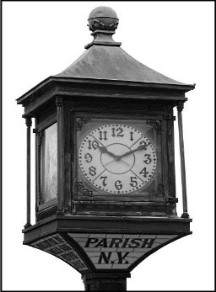

To All Interested Parties:

An Organizational meeting will be held to discuss placing banners in the Village/Town of Parish.

Bill Scriber has volunteered to head this wonderful project.

Date: January 14th, 2026

Time: 6:00pm

Place: Town/Village Hall 2938 E. Main Street, Parish NY

